EXPERIMENT N0 1

AIM: To write an assembly language program to implement 8 bit addition using 8085 processor to implement 8 bit using 8085 processor.

ALGORITHM:

1. Start the program by loading the first data into the accumulator.
2. Move the data to a register.
3. Get the second data and load it into the accumulator.
4. Add the two register contents.
5. Check for carry.
6. Store the value of sum and carry in the memory location.
7. Halt.

PROGRAM:

LDA 8500

MOV B,A

LDA 8501

ADD B

STA 8502

RST 1

INPUT

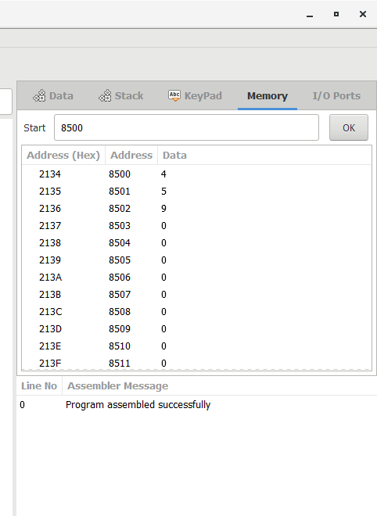

RESULT

Thus the program was executed successfully using 8085 processor simulator